How my autism diagnosis could help how you feel about Brexit

www.justinegaubert.com

My name’s Justine.
And I speak in a monotone voice.
(But that’s not all).

I also…
- Speak too fast
- I speak over people
- The words in my head aren’t always the same as the ones that come out of my mouth. I can speak for HOURS on topics that I find fascinating….
- (but don’t seem to realise when YOU don’t).
- But WORST OF ALL!
- I sometimes have PROBLEMS
- With memory.

Lucky for me then, that the theme for today is BEYOND EXPECTATIONS.
And I didn’t want any of THAT, to stop me from doing THIS.

This is why one of you will have a found a copy of my talk on your seat when you came in.
Could you wave it in the air?
I wondered if you could help me out...
If at any point in the presentation I look like this…
{Pull face}
...for longer than five seconds? If you could throw me the line and we can crack on, thanks!

………………………………………………..

Picture the scene.
I’m 9 years old and I’m standing in my grandfather’s kitchen.

He’s just put some bread under the grill,
And as he leaves the room, he leaves me with one, simple instruction…

“Watch the toast.”

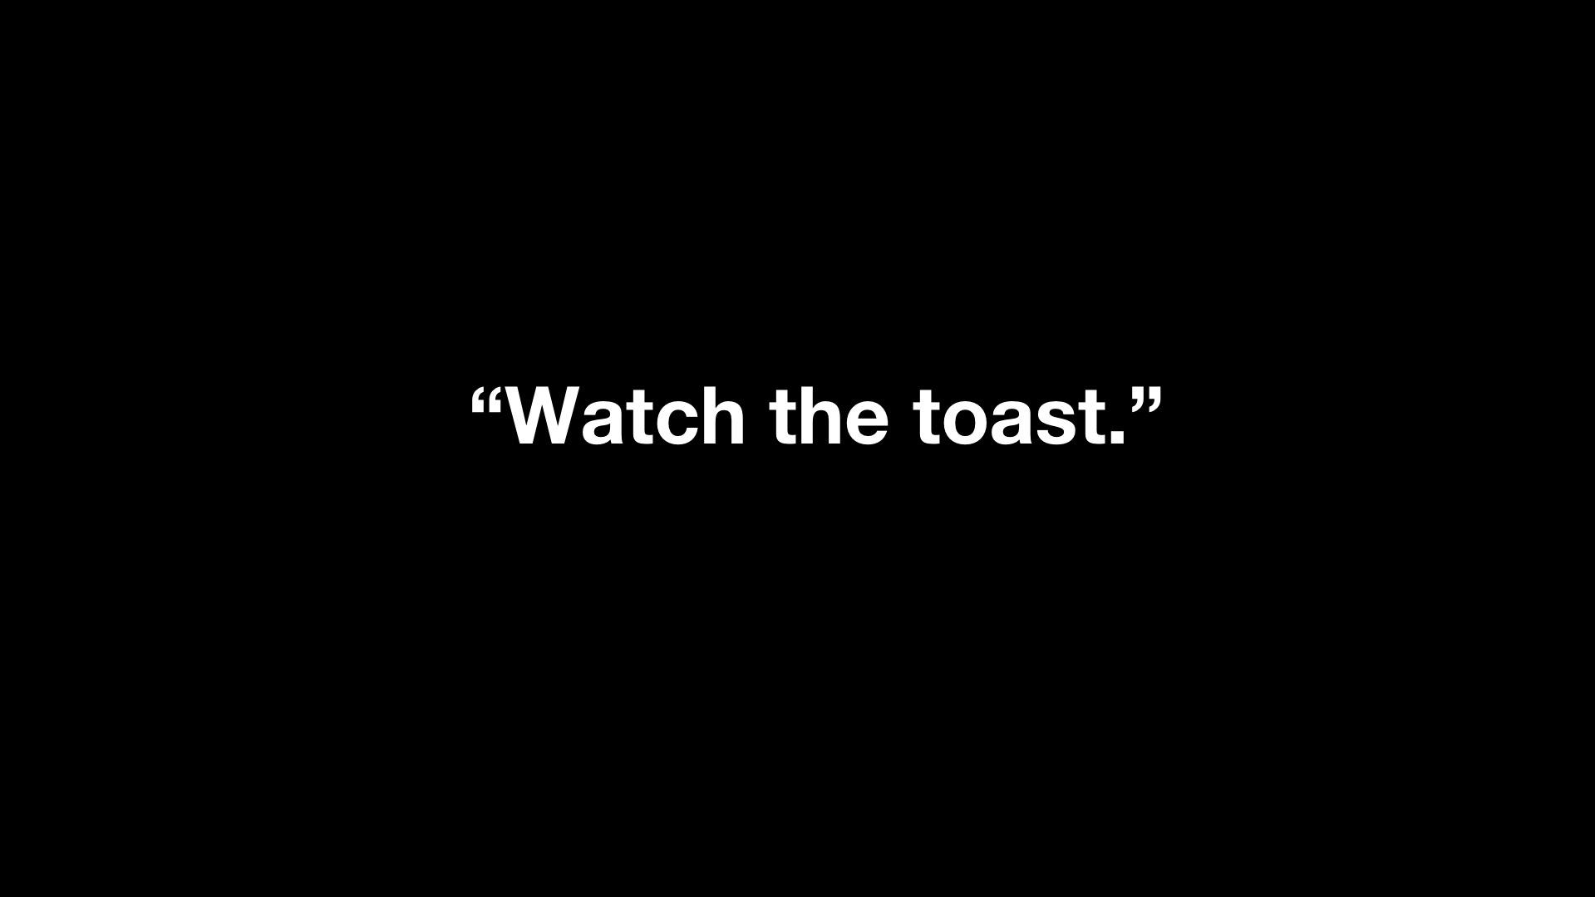

Several minutes later…

Quite possibly alerted by the smell of burning toast…
...or maybe by the SIGHT of the black smoke creeping under the kitchen door.
...or maybe by the DEAFENING RING of the fire alarm.
...he comes BACK into the kitchen.
And through the black smoke,
He can JUST ABOUT make me out…
...Still standing DUTIFULLY by the grill…
“Watching the toast.”

“Why can’t people just say what they mean?!”
Still… I suppose it could have been worse…
...he could have asked me to keep an eye on it!

…………………………………………………

I have a lifetime of stories
Where I got something wrong
Because I didn’t understand the mind of somebody else.

Stories which left me wondering
If I had been born on the wrong planet.
A planet with hidden or illogical rules
And no text book to navigate them.

...Stories that often left me feeling… broken.

………………………………………………...

As we all do, I developed a survival strategy
For dealing with my shameful stories and broken pieces..
...I hid them.
And I dedicated my life to
Peddling frantically
Behind a secret curtain.
TERRIFIED that at any moment,
Someone might look behind the curtain,
And see just how many broken bits there actually were…

………………………………………………….
There have been times, where I MENTALLY
Could not HOLD UP THE CURTAIN any longer.
And THIS happened…

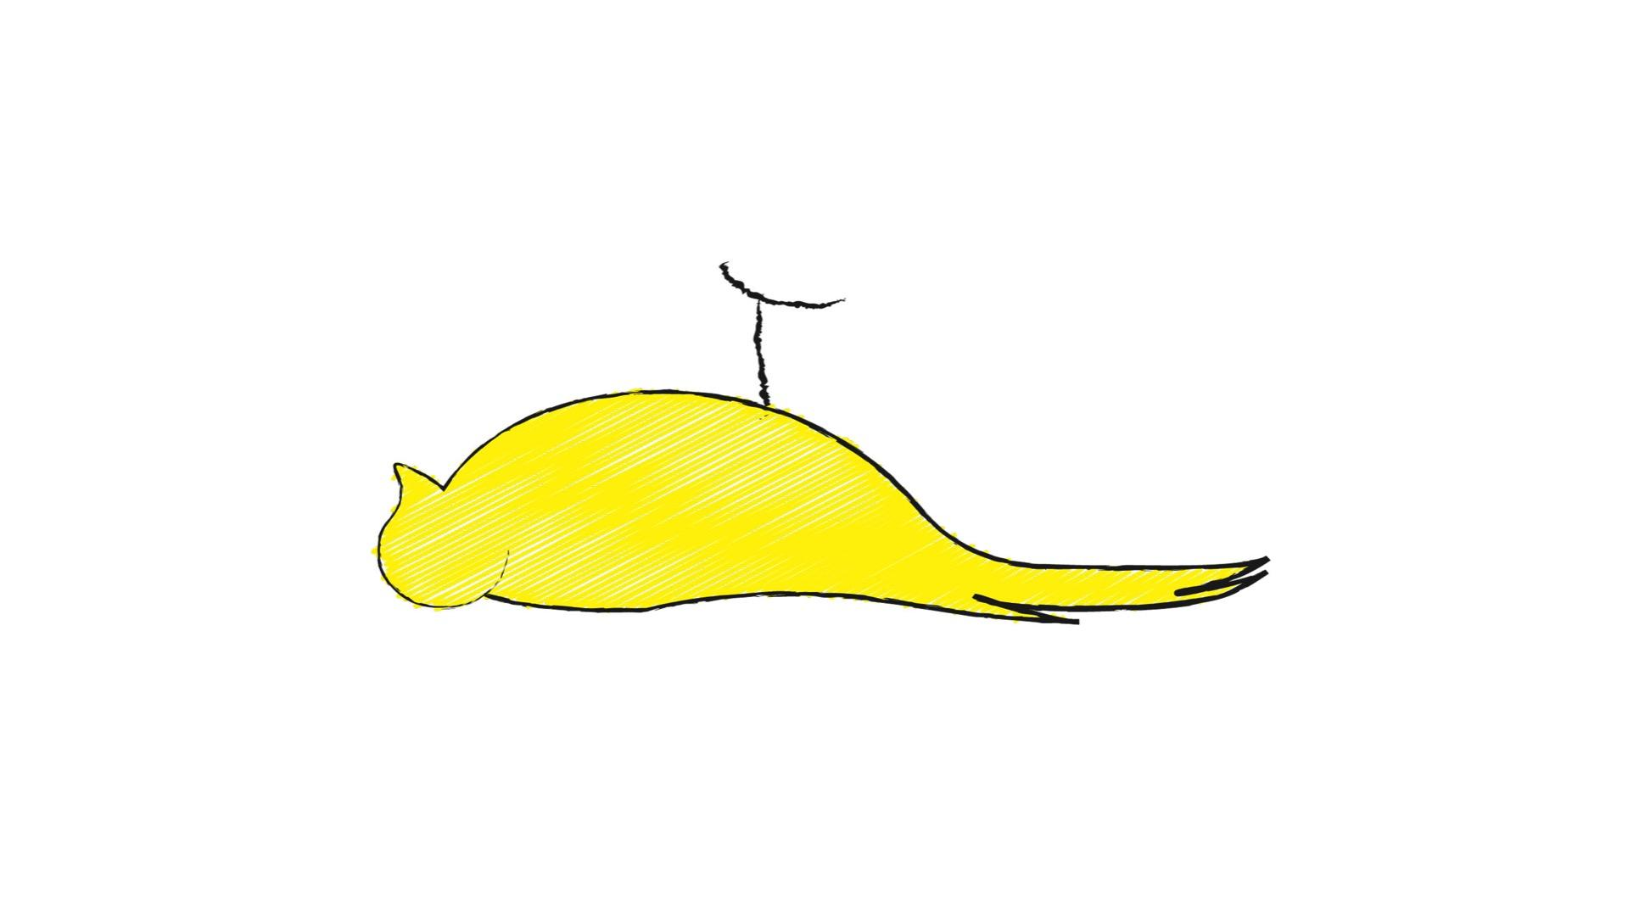

I’d meltdown.

And it was as I was coming out of a particularly dark period,
One of the closest times I’d ever had to not being here anymore.
That I made a commitment to MYSELF and my family
To ONCE AND FOR ALL, get to the bottom of why THIS
Kept happening.

And so I RESOLVED to empty all my broken pieces onto the floor.
And I made a PLEDGE to…

#GET CURIOUS.

…………………………………………………...

Over several years I ‘got curious’ about myself,
And ESPECIALLY the bits I didn’t like.

I became more open with people about how I experienced the world,
And this is how I met a wonderful CBT therapist called Sarah,
...And it was Sarah who gently suggested that I might be autistic
and offered to refer me for a diagnosis.

This is how, aged 45 (and three quarters)

I received a diagnosis of AUTISM SPECTRUM DISORDER (Or Aspergers)

And for the first time in 45 years,
I felt someone had FINALLY slipped me
The right text book under the curtain…
...Put a hand on my shoulder

And whispered:
“You’re alright, love.
You can stop peddling now.”

…………………………………………………..

Getting a diagnosis, a name, A LABEL!
Was CRITICAL to helping me ‘get curious’
And to helping me understand my difficulties.

That’s because if you’ve got a NAME,
You can google it.
And if you can GOOGLE IT…
You can find a book about it.
And if you find a book about it,
You can find a new language,
And my new language
WAS THE LANGUAGE OF SCIENCE!

ARMED with my new lexicon, I found that I started to re-write some of my stories of shame
Through a KINDER, more COMPASSIONATE lense.
And so it was that my shameful…

“Watch the toast” story…

Now became…

A Story of LEARNING.

A Story of COGNITIVE SCIENCE

A Story that illustrates a CONCEPT that many believe to be at the HEART of our understanding of autism, called…

...Theory of Mind

And I LEARNT that people like me, often have a DEFICIT
In Theory of Mind, which means
We can often struggle to imagine the mind of somebody else.

And it was learning about Theory of Mind that also made me wonder if
My deficit in that area, could also be a contributing factor to some of the stuff I’m actually GOOD at too!
Like being a consultant? (Which is one of the jobs that I do.)

I’m sure you’ve all heard the adage…

...ASSUME makes an ass out of YOU and ME?

Well, the WORST thing a consultant can do is ASSUME.
But because of my deficit in theory of Mind,
I
Assume
NOTHING.
And it leaves me NO CHOICE
But to ask questions.
LOTS of questions.

And one question in particular…

“Yeh but WHY!”
(And anyone who has seen Simon Sinek’s ted talk will know the importance of THAT QUESTION!)

This then made sense of the type of feedback I’ve had from clients over the years. Feedback like this…
“Justine has a unique ability to get under the skin of an organisation.”

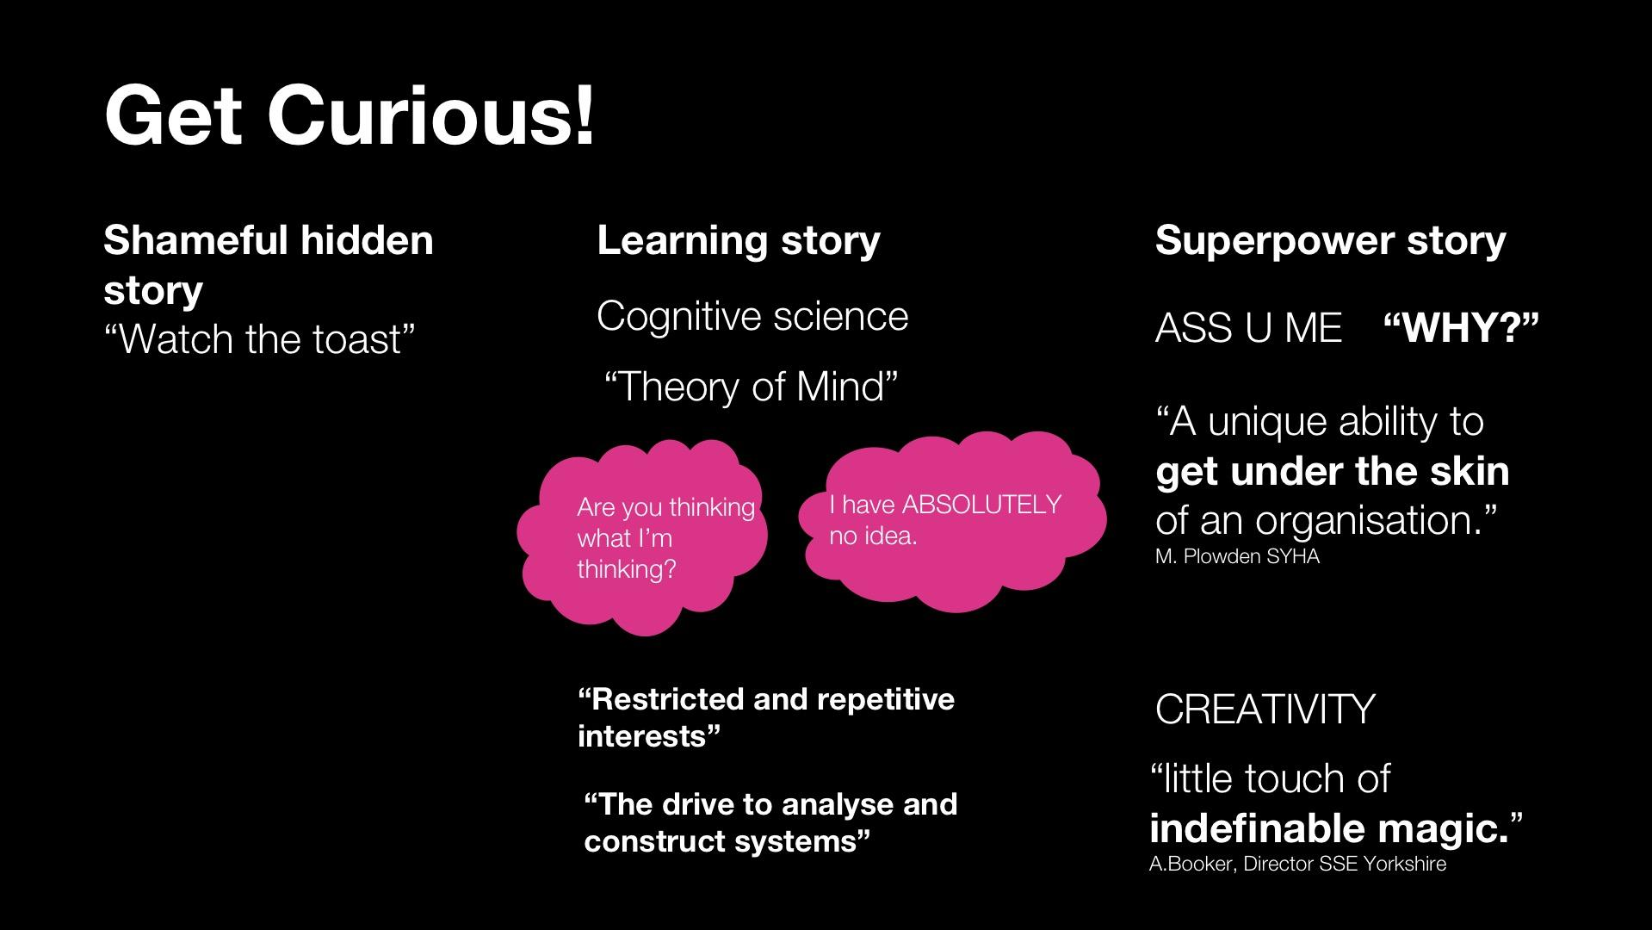

I then started to wonder about OTHER autistic deficits.
Deficits like…

“Restricted and repetitive interests”

And

‘Pattern spotting’ - our autistic drive to make connections between things.

...Could these deficits also be contributing factors to the most ILLUSTIVE superpower of all…

CREATIVITY

...that “little touch of indefinable magic.’

………………………………………………………………….

Here’s an example.

A few years ago I was given a brief from South Yorkshire Housing,
To come up with a name and a campaign for a new residential development
In an area in Sheffield called ‘Kelham Island’.

In the 10 minutes it had taken me to get home on the tram…

My AUTISTIC DRIVE to MAKE CONNECTIONS
between my ‘restricted and repetitive interests’, went something like this…
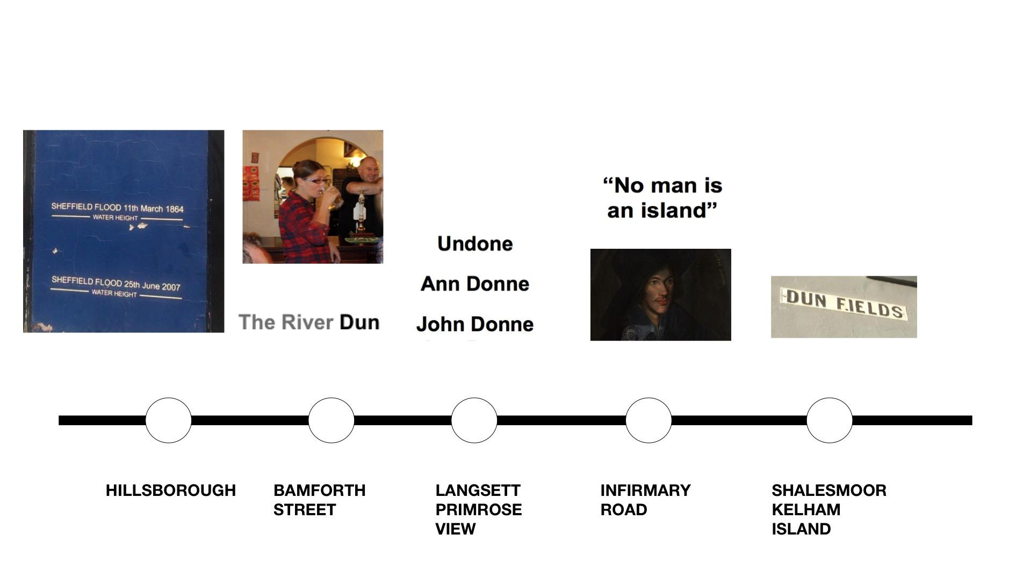

The name of the road where the development was going to be BUILT was called…

...Dun Fields Road.

This then sparked my FIRST ‘restricted and repetitive interest’, the metaphysical poet, John Donne.

(‘No man is an island’)

...and in particular, it reminded me of a letter he’d written, that had ended with the phrase…

John Donne
Anne Donne
Undonne

And this reminded me of a second ‘‘restricted and repetitive interest’
My love of Sheffield Rivers.
(And Doncaster rivers are alright as well).
And one river in particular…
THE RIVER DON....or the river DUN

...as I’d learnt it was called in celtic times.

This then brought to mind my absolute FAVORITE restricted and repetitive interest…

My love of REAL ALE...
And in particular

the FLOODLINES
That are painted
on the side of the Fat Cat pub in Kelham Island,

...which show the WATER LEVELS when the RIver DUN broke its banks In the Great Sheffield Flood of 1864.

NOW, before I’d even got off the tram...The whole campaign had played itself out in my mind With such CLARITY,

That I knew we’d call it

‘Dun Works…’

And that on the HOARDINGs around the building site, we’d have…

NOT DUN
NEARLY DUN
ALL DUN

And that we could then play with that message across a range of campaign items like…

WELCOME MUGS for tenants.

Which again would reflect the floodlines from the Fat Cat pub.

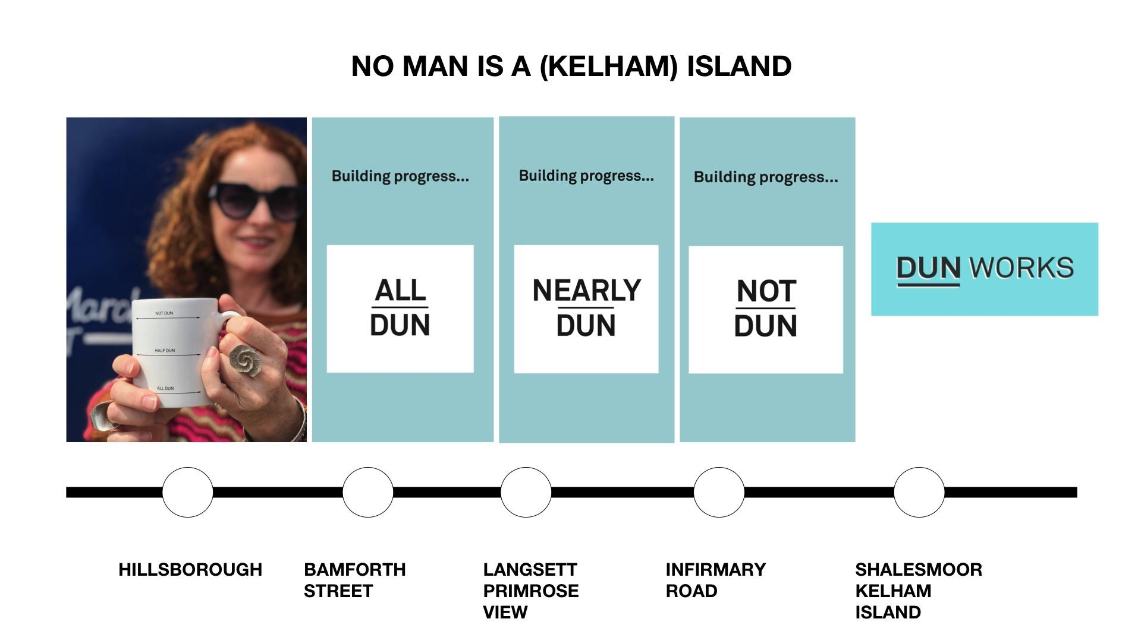

...I think I suggested toilet roll as well (for the dunny, obviously)
But they rejected that, proving, if nothing else that…

NO (WO)MAN IS A KELHAM ISLAND!
(I bet you weren’t expecting metaphysical conceit jokes from an autistic person when you got up this morning were ya?!... “Beyond Expectations.”

…………………………………………………………………..

DURING the process of ‘getting curious
Something really interesting happened…
(Pause)
I started to feel an actual
PHYSICAL SHIFT inside myself.

A shift that took me from…

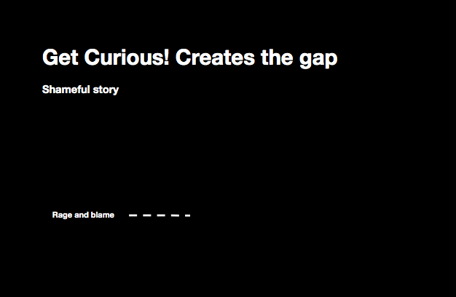

RAGE AND BLAME
To…

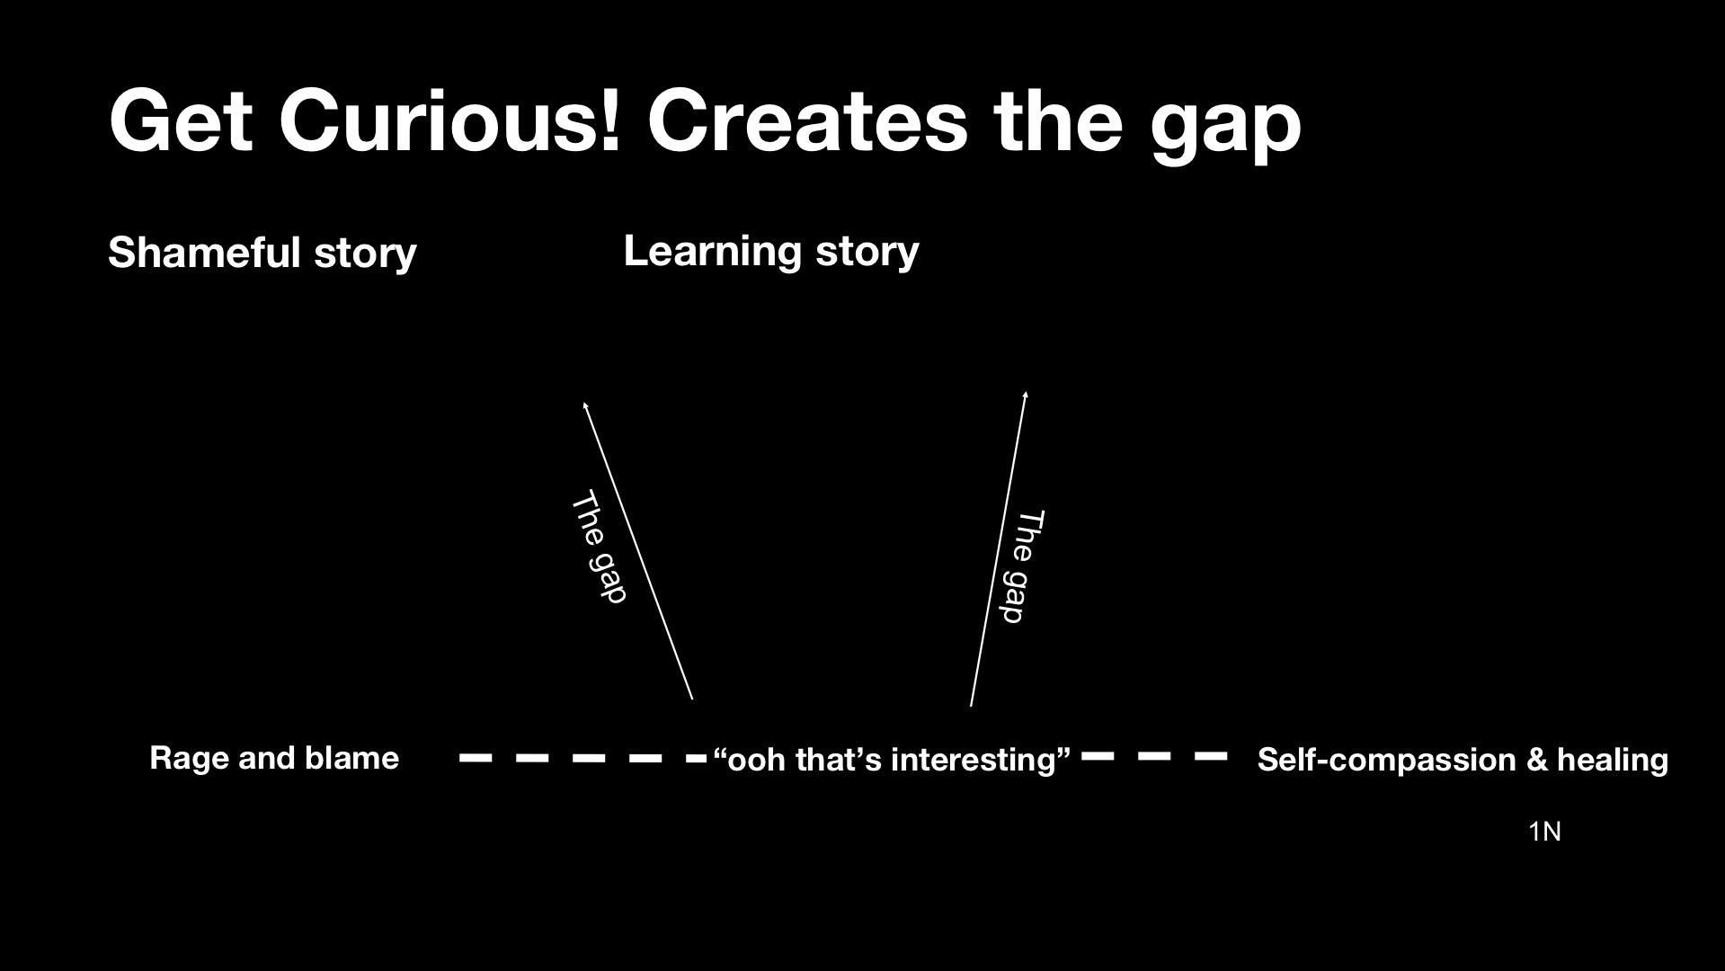

“Oo that’s interesting!”

And it was somewhere in this shift,
that created JUST ENOUGH OF A GAP...
...to start letting in just a TINY BIT of self compassion.

Which started to move me towards a place of healing.
Then I started to wonder if there was any NEUROSCIENCE behind this SHIFT…

And I learnt how I’d spent a large chunk of my life in…

‘FIght or flight’ mode.

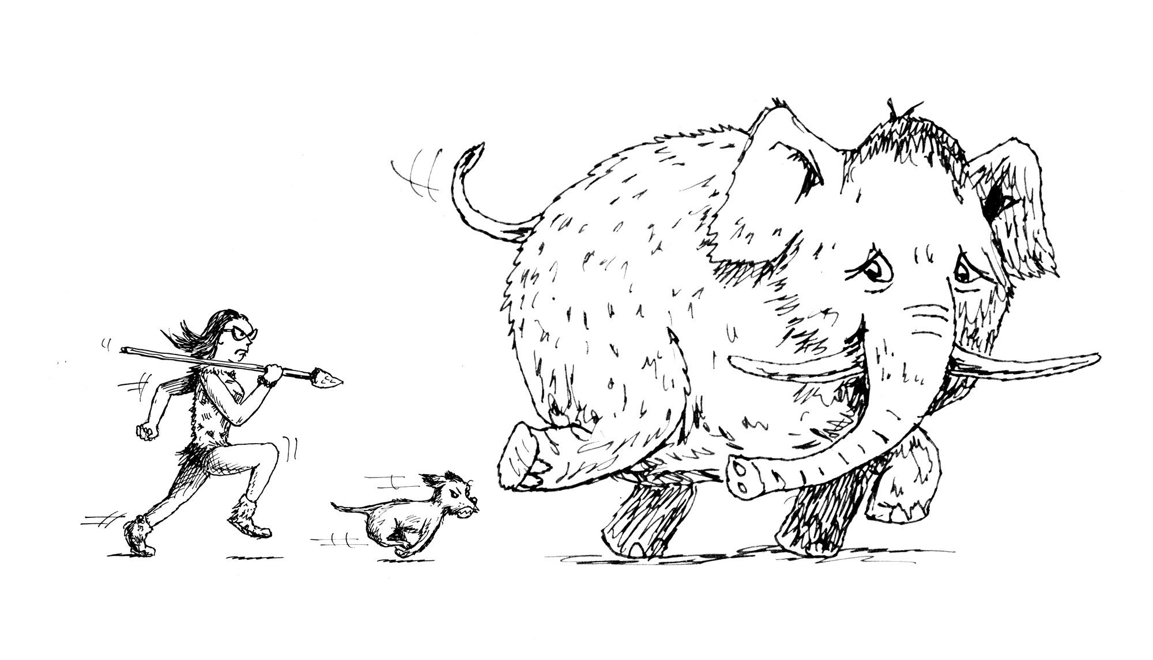

Or…

“Amygdala hijack”...
...As I learnt it was called.

And I learnt that when you’re in an “Amygdala hijack”...
The whole of your pre-fontal cortex
(Which is the LEARNING AND THINKING PART OF OUR BRAIN…)
COMPLETELY shuts down.

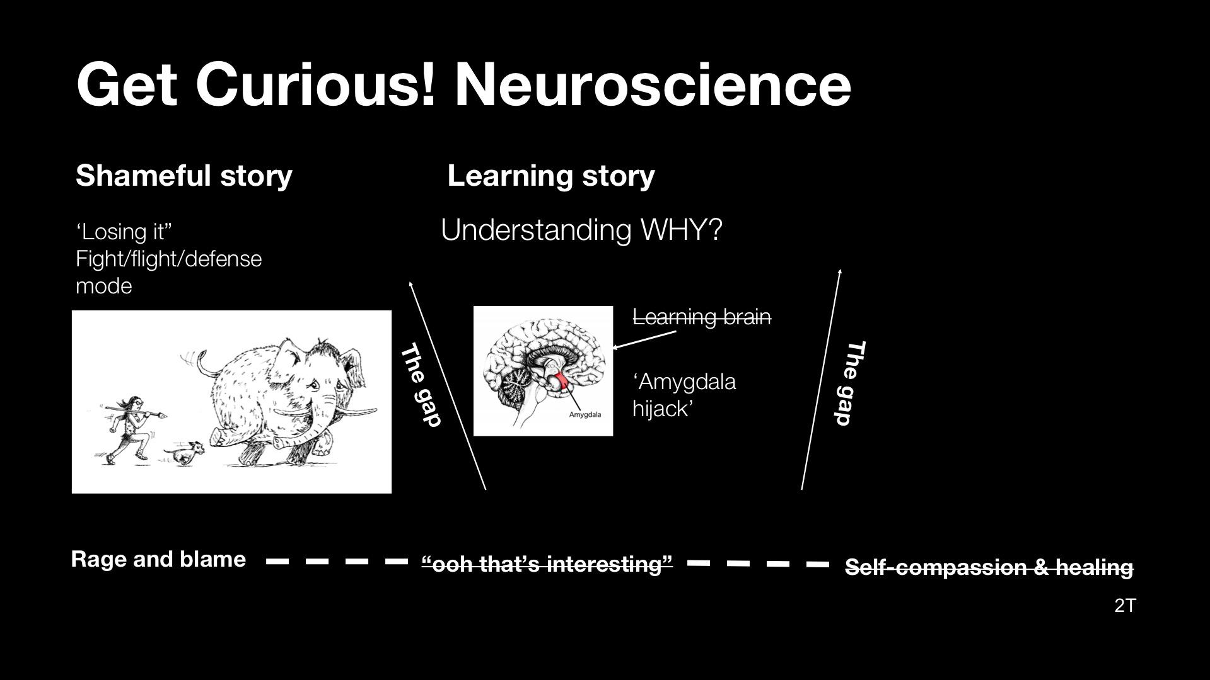

And yet I knew that THIS
Was where I actually needed to be
In LEARNING MODE
If I was ever going to create the gap

...for self compassion.
...and move towards a place of healing.

Turns out… I’m not the first person to discover the benefits of the healing powers of curiosity.
Any Cognitive Behaviourial Therapists in the room… will know it.

In 400 BC, the BUDDAH knew it.
...Come to think of it, so did Socrates around the same time.

IN FACT.
Every culture.
Every generation.
Re-learns the healing power of curiosity.
So with all that in mind, you’d think WE’D
have learnt this lesson by now
Right?!
……………………………………………………………

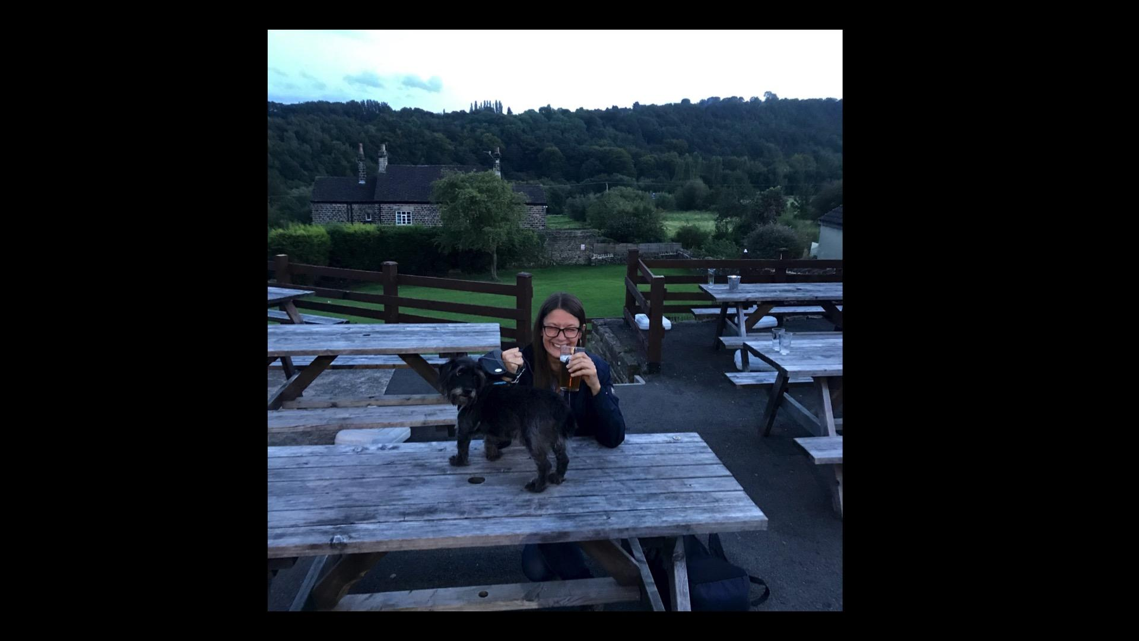

This is a picture of me and Stan outside our local pub.
… at least it WAS our local, until a friendly chat with the lovely owner
Turned to the topic of...Brexit...and then U.S Politics...
And….BANG!
There I was… back in FULL FIGHT mode.
I wasn’t in… LEARNING MODE!
I wasn’t exploring his broken pieces from a place of curiosity and learning!

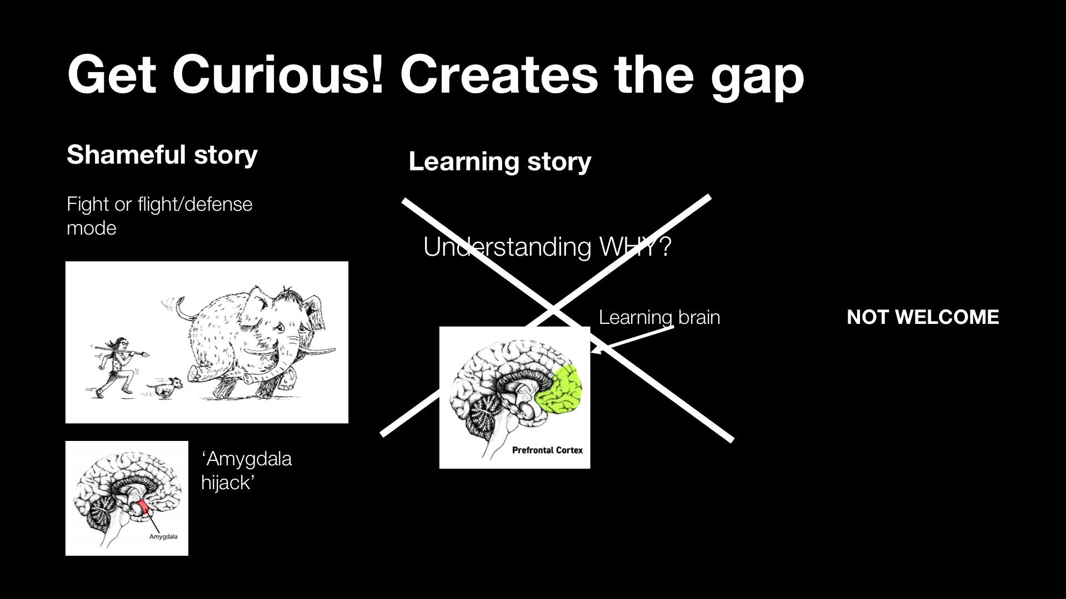

...reason
logic
understanding
compassion
...had all left the building.

And then.
So.
Did.
We.

……………………………………………….

Now whatever your views are on Brexit
Or U.S politics.
Or Brazil.
Or, well, you name it at the moment,
There’s ONE THING, we can surely all agree on.

And that is, our world has FRACTURED.
And all our shameful, broken pieces are out on display
RIGHT NOW for the whole world to see.

But rather than seizing this unique opportunity to pick up and explore each others broken pieces, we’re still stuck here! {point to rage and blame}

In rage and blame.
When we really need to be HERE! [point to learning mode]
...in learning mode.

……………………………………………………..

The Japanese have an artform called...

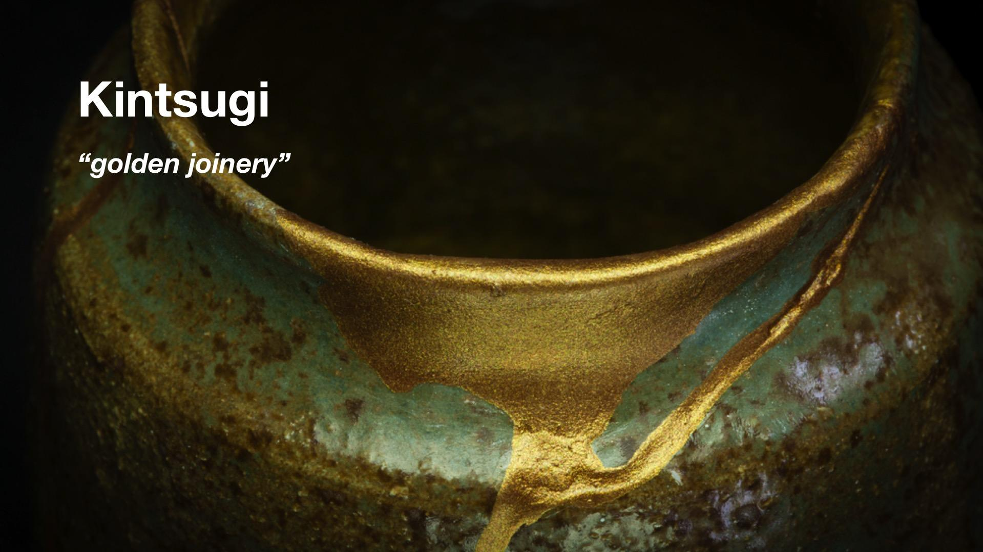

…”kintsugi”
Or “Golden joinery”
Which is the art of repairing broken pottery with powered gold.

They see breakage and repair as part of the HISTORY of an object
Rather than something to be HIDDEN or DISGUISED.

And I realised that although I’d started to make a pretty decent job of ‘kintsugiying’ myself…
(To the extent that I’m not hiding my cracks any more, I’m doing TED talks about them!)
But the Brexit meltdown made me realise
That just getting curious about MYSELF, just wasn’t going to be enough.

If we’re going to start putting our world back together, we need to be
GETTING CURIOUS ABOUT EACH OTHER.

………………………………………………………

So here’s my challenge to you.

It’s to go BEYOND YOUR EXPECTATIONS OF OTHERS…

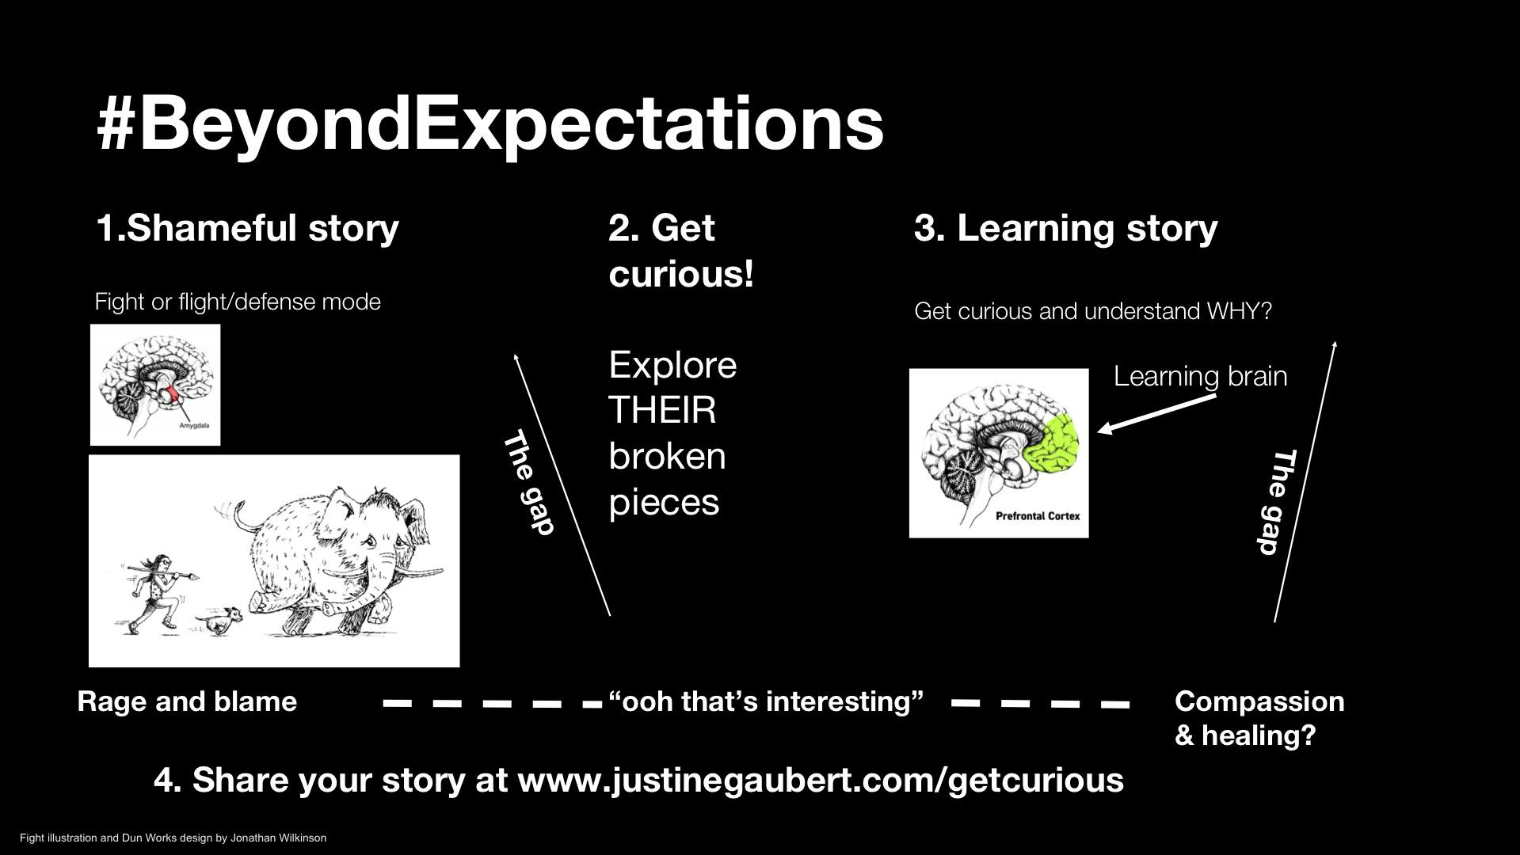

And to GET CURIOUS with just ONE PERSON from outside of your own echo chamber,
But to have that conversation from a place of CURIOSITY,
Rather than “Rage and blame”.

Could this help create JUST ENOUGH OF A GAP, to let in the light of compassion, and move us towards a place of healing?

And when we’ve had those conversations, let’s not paper over the cracks and pretend this never happened, because that’s EXACTLY what got us into this mess in the first place!

Instead, let’s use the healing process to show the best of ourselves.
And let’s start putting our world back together…
...with powdered gold.
...Turns out, I’m not the first person to think of this either!

So I want to leave you with a few lines from my old boss’ favourite, the writer and singer,
Leonard Cohen.

“Ring the bells that can still ring.
Forget your perfect offering.
There’s a CRACK in EVERYTHING.
...It’s how
The light
Gets in.”

(End)

